Complier Design
Project Report
(Cloud Deployment DSL Compiler )
Computer Science Department
November 3, 2025

Contents

1. Introduction
1.1 Project Overview …………………………………………………………………………. 5
1.2 Motivation………………………………………………………………………………… 5
1.3 Objectives…………………………………………………………………………………. 6

2. System Architecture
2.1 Compiler Pipeline Overview………………………………………………………………7
2.2 Lexical and Syntax Analysis Flow……………………………..…………………………7
2.3 Technology Stack…………………………………………………………………………..7
2.4 Project Structure…………………………………………………………………………....7

3. Interface Testing and Validation
3.1 Command-Line Interface (CLI)…………………………………………..……………….8
5.2 Input and Output Workflow……………………………………………………..…………8
5.3 Example Run Demonstration………………………………………..……………..……..8
6.1 Build and Execution Testing…………………………………………………………..…..8
6.2 Debugging and Error Detection…………………………….………………………..……8
6.3 Sample Test Cases………………………………………………………………….……..8

4. Implementation Details
4.1 Lexical Analysis (Flex)……………………………………………………………………9
4.2 Syntax Analysis (Yacc/Bison)……………………………………………….…………..12
4.3 - 4.4 Abstract Syntax Tree (AST) Design…………………………………….….…….16
4.5 Optimization Phase………………………………………………………………..……..19
4.6 Code Generation………………………………………………………………………….20
4.7 Main Driver Integration……………………………………………………………….…..20
4.8 Make file Configuration……………………………………………………………….….22
4.9 Sample Input and Output Configuration ………………………………….…………….23

5. Supported Features
5.1 DSL Language Constructs……………………………………………………….. 24
5.2 Optimization Features……………………………………………..……………….24
5.3 JSON Output Generation………………………………………………….……….24
5.4 Error Handling and Validation……………………………………………….……..24

6. Challenges and Solutions
7.1 Lexical and Parsing Issues…………………………………………………………. 25
7.2 Semantic and Structural Challenges………………………………………….……25
7.3 Design and Optimization Challenges……………………..………………………..25

7. Results and Future Enhancements
8.1 Functional Objectives………………………………………………………….….. 26
8.2 Educational Outcomes……………………………………………………………..26
8.3 Performance Summary…………………………………………………………….26
8.4 Planned Improvements………………………………………….…………………26
8.5 Possible Extensions……………………………………………………….……….26

8. Debugging And Testing
8.1 Testing and Analysis ………………………………………….………….………..25

9. Conclusion
10.1 Summary of Work……………………………………………….…………….….27
10.2 Key Learnings……………………………………………………………………..27
10.3 Final Remarks……………………………………………………………………..27

By Team G-force
Members
M1: R U Vijay Pranav (CS23B1073)
M2: ManiKanta (CS23B1072)
M3: Avinash Kumar (CS23B1080)
M4: Nisarg (CS23B1090)

1. Cloud Deployment DSL Compiler — Detailed Project Explanation

1. 1 Project overview (Abstract)
The Cloud Deployment DSL Compiler is a compact domain-specific compiler that parses human-friendly deployment descriptions (a small DSL), constructs an internal Abstract Syntax Tree (AST), performs simple optimizations, and emits a machine-friendly JSON deployment plan.

The front end is implemented with a Flex lexer (lexer.l) and a Yacc/Bison parser (parser.y), the AST and semantic helpers are in ast.h / ast.c, optimizations live in optimizer.c, and the final plan is produced by codegen.c.
A Makefile automates building Process.

1.2 Motivation
In today’s rapidly evolving cloud computing ecosystem, developers and system administrators frequently face the challenge of configuring and deploying applications across multiple cloud providers such as AWS, Azure, and Google Cloud.
Each provider has its own configuration syntax, deployment format, and optimization strategies, making multi-cloud deployments error-prone, time-consuming, and difficult to maintain.
To address these challenges, we were motivated to design a Domain Specific Language (DSL) that simplifies and standardizes the way cloud deployments are defined.
Our DSL allows users to specify key deployment parameters—such as provider, region, services, resources, and optimization goals—in a clean, human-readable format.
The compiler for this DSL then parses, analyzes, and converts these specifications into a structured deployment plan (in JSON format) that can be easily extended for automation or integration with cloud APIs.

In short, our motivation lies in:
- Reducing the complexity of writing cloud deployment configurations.
- Creating a unified syntax for cloud resource descriptions.
- Automating the generation of deployment plans using compiler design principles.
- Demonstrating how traditional compiler techniques (lexing, parsing, code generation) can be applied to real-world DevOps scenarios.

1.3 Objectives
The key objectives of the Cloud Deployment DSL Compiler project are:
- Design a custom DSL for describing cloud deployments in a simplified, human-readable form.
- Implement lexical and syntax analysis using Flex and Yacc (Lex and Yacc tools) to parse the DSL code.
- Construct an Abstract Syntax Tree (AST) to represent deployment structures such as services, constraints, and environments.
- Apply basic optimization techniques to adjust parameters (e.g., CPU, replicas) for cost and latency improvements.
- Generate structured output (in JSON format) to represent deployment plans that can be further processed or used for cloud automation.
- Ensure modular design, with separate files for lexical analysis, parsing, AST construction, optimization, and code generation.
- Demonstrate compiler workflow, including scanning, parsing, semantic representation, optimization, and output generation.
- Provide an extensible foundation, allowing future enhancements like multi-cloud deployment translation or integration with real APIs.

2. High-level architecture and pipeline Explanation

2.1 Complier pipeline overview
The compiler follows a classical pipeline:
- Lexical analysis (Flex) — lexer.l reads the input .ddl file and converts text into tokens (keywords, identifiers, numbers, strings, symbols).
- Parsing (Yacc/Bison) — parser.y consumes tokens and applies grammar rules to recognize program structure (deployment, services, env blocks, constraints). Semantic actions in the parser build the AST using functions in ast.c.
- AST (Semantic model) — ast.h / ast.c define the data structures (Deployment, Service, EnvVar, Constraint) and helper functions to construct and manipulate them.
- Optimization — optimizer.c takes the AST and applies optimization passes (example: increase replica counts to satisfy constraints).
- Code generation — codegen.c serializes the optimized AST into a JSON-formatted deployment plan.
- Main driver — main.c ties everything together: opens input, calls parser, runs optimizer, calls emitter, cleans up.
At each stage data flows via C data structures (pointers to structs), so components are linked by function calls and shared headers.
2.4 Project Structure:

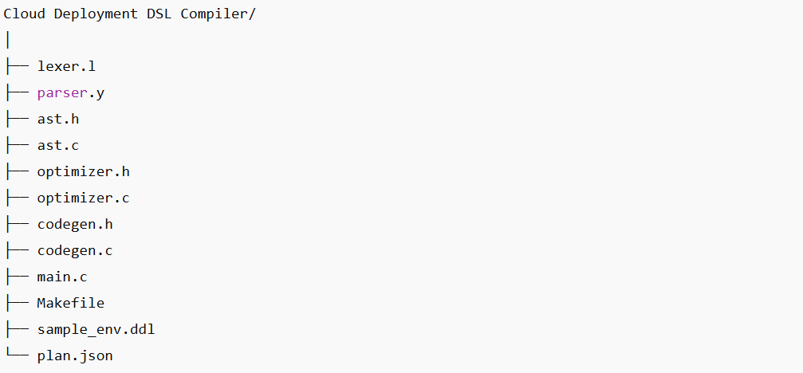

3. How to build and run
Assuming you are on Ubuntu / WSL with flex, bison (or yacc) and a C toolchain installed:

# Clean and build
make clean
make
# Run with sample input and capture JSON output
./cloudopt sample_env.ddl > plan.json

# Or debug build:
cc -g y.tab.c lex.yy.c ast.c optimizer.c codegen.c main.c -o cloudopt_dbg -ll
./cloudopt_dbg sample_env.ddl

Extra Notes Point :
- If you want debug logs separated from JSON, direct debug prints to stderr and JSON to stdout.
- If you see "Clock skew detected" warnings, run make -B to force rebuild or fix host/WSL time sync.

4. File-by-file explanation
Below I Have explain each important file in the project, what it contains, and how it connects to other files.

4.1 lexer.l — lexical analyzer (Flex)
Purpose: Tokenize the DSL input. Recognizes keywords, identifiers, numbers, strings, and punctuation.
Key parts:
Header block:
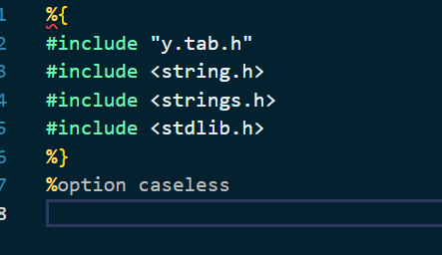

%option caseless
  - Includes y.tab.h (parser-generated token definitions).
  - %option caseless (make matching case-insensitive). Additionally, keyword checks use strcasecmp for robustness.

- Token rules:
  - Whitespace ignored:
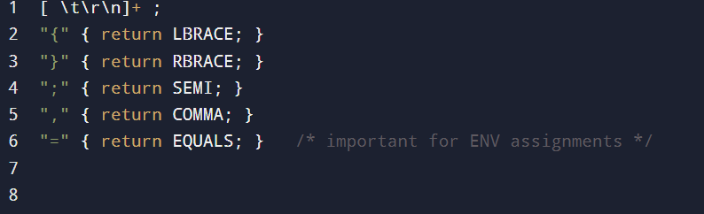
String literal rule:
  - \"[^\"]*\" { yylval.str = strdup(yytext + 1); yylval.str[strlen(yylval.str)-1] = '\0'; return STRING; }
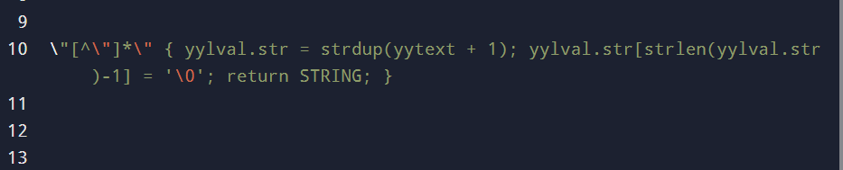
Number rule:
  - [0-9]+ { yylval.num = atoi(yytext); return NUMBER; }
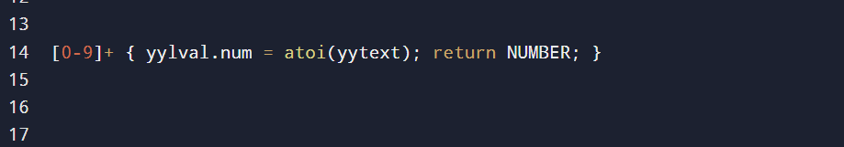

Identifier / keyword rule:
  - [a-zA-Z_][a-zA-Z0-9_-]* {
  - if (strcasecmp(yytext,"deployment")==0) return DEPLOYMENT;
  - ...
  - yylval.str = strdup(yytext);
  - return ID;
  - }
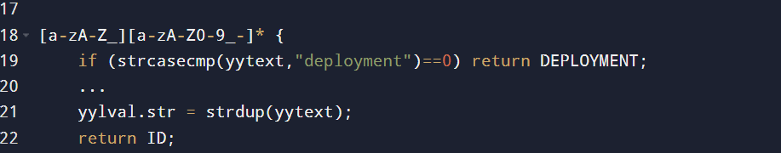

This block checks keywords (case-insensitive) and otherwise returns ID with semantic value in yylval.str.
Connections:
- Returns tokens declared in parser.y (via y.tab.h).
- Populates yylval so parser actions can receive lexeme strings/numbers.

Important implementation notes:
- strcasecmp matches uppercase/lowercase keywords.
- Returning EQUALS for = is crucial because parser grammar expects a named token EQUALS.

4.2 parser.y — grammar & semantic actions (Yacc/Bison)

Purpose: Parse sequences of tokens into AST nodes and wire them together; also handles some basic semantic checks.
Top-level structure:
%union lists types stored in yylval:
%union {
char *str;
int num;
Service *svc;
Constraint *con;
Deployment *dep;
EnvVar *env;
}

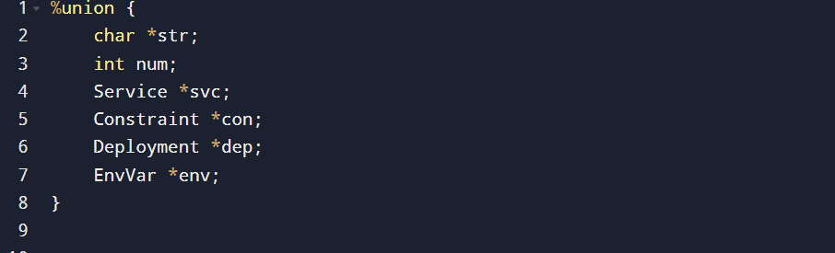

============================================
token declares tokens and types:
%token <str> ID STRING
%token <num> NUMBER
%token DEPLOYMENT PROVIDER REGION SERVICE IMAGE CPU MEM REPLICAS OPTIMIZE COST LATENCY ENV TRUE FALSE
%token LBRACE RBRACE SEMI COLON LPAREN RPAREN COMMA
%token EQUALS

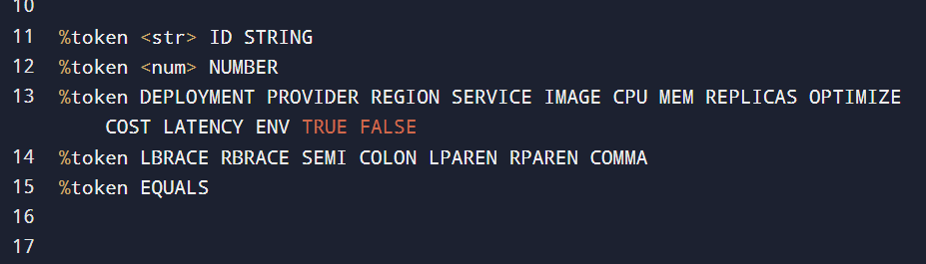
=============================================
deployment grammar (core):
deployment:
DEPLOYMENT ID LBRACE
{ root_deployment = create_deployment($2); free($2); }
dep_body RBRACE
{ $$ = root_deployment; root_deployment = NULL; };

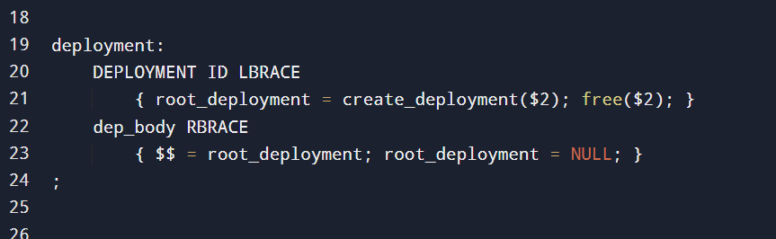

This creates the Deployment AST node early (so dep_item actions append details to it).
- dep_item includes PROVIDER, REGION, service, and OPTIMIZE blocks.
- The OPTIMIZE rule consumes the trailing SEMI to match the DSL style: OPTIMIZE { ... };.
==============================================
service rule:
service:
SERVICE ID LBRACE svc_body RBRACE SEMI
{
Service *s = create_service($2);
free($2);
add_service(root_deployment, s);
};

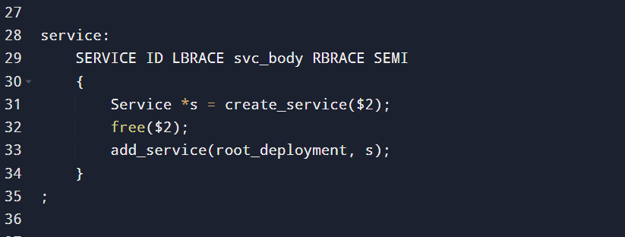

Each service is created and added to the current deployment.
- svc_item supports IMAGE STRING;, CPU NUMBER;, MEM NUMBER;, REPLICAS NUMBER;, and ENV { ... };.
- env_list / env_item:
==============================================
env_item:
ID EQUALS STRING SEMI { $$ = create_env($1,$3); free($1); free($3); }
;

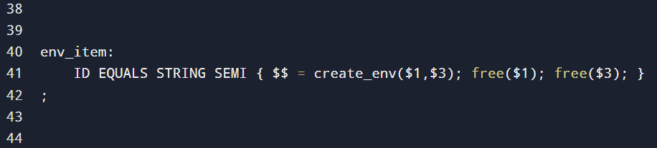
==============================================

create_env returns an EnvVar* which is appended and attached to the latest service by add_env.

Constraint parsing:
constraint:
COST NUMBER SEMI { $$ = create_constraint(CON_COST,$2); }
| LATENCY NUMBER SEMI { $$ = create_constraint(CON_LATENCY,$2); };

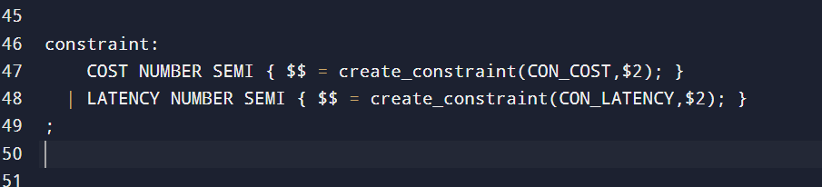

Semantic actions:
- The parser calls functions in ast.c to create nodes and link them (e.g., create_deployment, create_service, set_provider, add_service, create_constraint, append_constraint, create_env, append_env, add_env).
Error handling:
- yyerror(const char *s) prints parse errors to stderr. During development, breakpointing yyerror in gdb was used for debugging.
Connections:
- Relies on tokens from lexer.l and AST helpers from ast.h/c.
- After successful parse, root_deployment points to a filled Deployment AST passed to optimizer and codegen.

4.3 ast.h — AST type definitions and API

Purpose: Declares the in-memory structures used as the semantic model and prototypes for manipulation functions.
Key types:
typedef struct EnvVar {
char *key;
char *value;
struct EnvVar *next;
} EnvVar;

typedef struct Service {
char *name;
char *image;
int cpu;
int mem;
int replicas;
EnvVar *env;
struct Service *next;
} Service;

typedef struct Constraint {
ConType type; // CON_COST or CON_LATENCY
int value;
struct Constraint *next;
} Constraint;

typedef struct Deployment {
char *name;
char *provider;
char *region;
Service *services;
Constraint *constraints;
} Deployment;

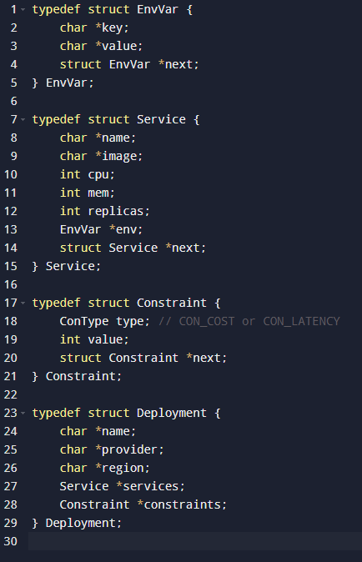
Key functions declared:
- Creation and mutation: create_deployment, create_service, add_service, latest_service, set_service_*, create_constraint, append_constraint, set_constraints.
- Environment helpers: create_env, append_env, add_env.
- Utilities: free_deployment, print_deployment.

Connections:
- Used by parser semantic actions and by optimizer & codegen.

4.4 ast.c — AST implementation
Purpose: Implements functions declared in ast.h: allocation, linking, string duplication, append functions, and cleanup.
Important details:
- Memory allocation: strdup used for string fields to isolate lexeme memory.
- create_service initializes env = NULL and default values (e.g., cpu=1, mem=512, replicas=1).
- append_env and append_constraint walk linked lists to append new nodes.
- free_deployment walks entire structure freeing all memory (services, env lists, constraints) — prevents leaks.
- print_deployment produces a human-readable debug printout used during testing.
Connections:
- Called by parser.y to build AST, by optimizer to update AST, and by codegen to emit output. free_deployment is called at program end or on parse failure.

4.5 optimizer.c / optimizer.h — optimization pass
Purpose: Run simple optimization passes on the AST — this demonstrates compiler transformation and constraint handling.
Example functionality (typical):
- Increase service replicas if constraints or some heuristic demands it (e.g., if latency is high, increase replicas).
- Constraint enforcement or selection of configuration values to meet COST or LATENCY constraints.
Implementation notes:
- The optimizer takes Deployment* and may produce a modified Deployment* (in place).
- The optimizer prints a debug message showing the AST before and after optimization (for demo).
- This module is intentionally simple to keep project scope reasonable while demonstrating a transformation stage.
Connections:
- Called from main.c after parsing and before code generation.

4.6 codegen.c — code / JSON generation
Purpose: Serialize the optimized AST into a JSON-like deployment plan that external tools can consume.
Key features:
- emit_service(Service *s, int first) prints JSON for a single service (name, image, cpu, mem, replicas, env array).
- emit_plan(Deployment *d) prints the full JSON object (deployment, provider, region, services array, constraints array).
Formatting notes:
- The emitted JSON is plain printf-based; careful comma handling and first flags avoid trailing commas.
- Env vars emitted either as empty array [] or list of key/value pairs like {"KEY": "VALUE"} depending on implementation.
Connections:
- Called by main.c after optimizer, using Deployment*.

4.7 main.c — program driver

Purpose: CLI entrypoint, orchestrates build pipeline:
Typical steps:
- Open input file (or read stdin).
- Set yyin to that file so flex reads it.
- Call yyparse() to run parsing and AST construction.
- If parse succeeds: print debug AST (optional), call optimizer, print optimized AST (optional), call emit_plan to write JSON.
- Cleanup: free AST, close files.
Command-line usage:
Usage: ./cloudopt <input.dsl>

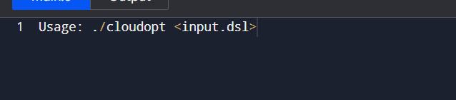
Connections:
- Uses yyparse, emit_plan, optimize functions. It is the glue.

4.8 Makefile
Purpose: Automates code generation and compilation:
Typical commands:
- yacc -d parser.y or bison -d parser.y → produces y.tab.c and y.tab.h.
- flex lexer.l → produces lex.yy.c.
- cc compile: cc -O2 -Wall y.tab.c lex.yy.c ast.c optimizer.c codegen.c main.c -o cloudopt -ll.
Targets:
- all or default: build cloudopt.
- clean: remove generated files (y.tab.c, y.tab.h, lex.yy.c, cloudopt, *.o).
Notes:
- If you use GNU bison, %code requires is accepted; POSIX yacc warns but still works. If warnings are unwanted, call bison directly or remove %code requires and include ast.h in parser header blocks.

4.9 sample_env.ddl and sample_input.ddl
Purpose: Example DSL input files used for testing.
Example content:
DEPLOYMENT MyApp {
PROVIDER aws;
REGION us-east-1;

SERVICE web {
IMAGE "nginx:latest";
CPU 1;
MEM 512;
REPLICAS 1;
ENV {
PORT = "8080";
MODE = "production";
};
};

OPTIMIZE {
COST 500;
LATENCY 80;
};
}

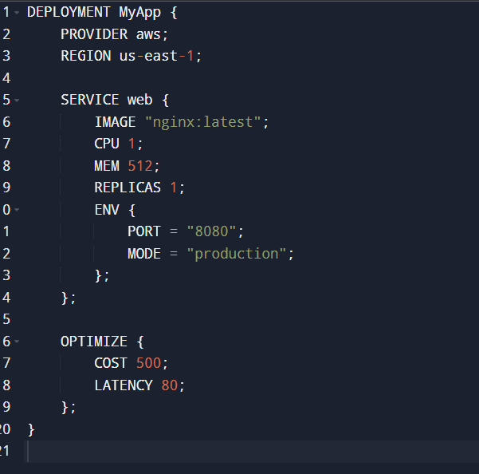

These files demonstrate:
- Keyword use (DEPLOYMENT, SERVICE, IMAGE, etc.)
- ENV block with KEY = "VALUE"; syntax
- OPTIMIZE block with constraints
Connections:
- Passed to ./cloudopt for parsing and to produce plan.json.

5. Data flow and runtime example
Parsing and AST build
- Lexer tokenizes: DEPLOYMENT → DEPLOYMENT token; MyApp → ID with yylval.str = "MyApp".
- Parser deployment rule executes semantic action: root_deployment = create_deployment("MyApp").
- Subsequent dep_item rules call set_provider, set_region, and for each service, create_service and add_service. ENV rules create EnvVar objects appended to Service->env.
Optimization
- optimizer.c inspects root_deployment->constraints and root_deployment->services, adjusts replicas, or tunes resource allocations.
Code generation
- codegen.c traverses the final Deployment AST and prints JSON. Example: a service with replicas changed from 1 to 2 by optimizer is reflected in output.
Sample run
./cloudopt sample_env.ddl > plan.json
cat plan.json
This writes JSON plan to plan.json. Debug and progress text printed to stderr remains on console; if you redirect both stdout/stderr to file you will capture everything.

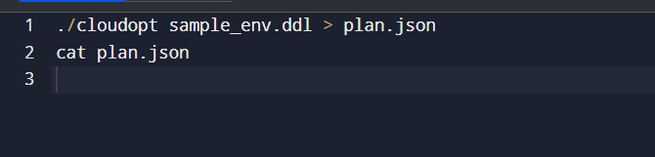

6. Debugging & testing notes
- Use gdb to debug parser and find exact syntax error points:
  - gdb ./cloudopt_dbg
  - break yyerror
  - run sample_env.ddl
  - bt to view parser call stack and inspect yytext, yylval, and root_deployment.
- Flex/Bison mismatch symptoms:
  - If keywords return as ID, check lexer’s keyword comparisons; use strcasecmp or %option caseless.
  - If = is not recognized, ensure lexer has "=" { return EQUALS; }.
- Use make clean && make -B to force full rebuilds when "clock skew" warnings occur.

7. Design choices & rationale
- Flex + Bison: classical compiler front-end tools; educational and robust.
- AST in plain C structs: simple, memory-efficient, and easy to manage in C — demonstrates pointer management, allocation, and cleanup.
- JSON output: practical target format (can be consumed by other tools).
- Small optimization pass: demonstrates that compiler can transform code — a key compiler capability (not just parsing).
- Case-insensitive keywords: practical for user convenience

8. Limitations and future extensions
This implementation is intentionally small for a student project. Possible extensions to make the project richer:
- Add more DSL constructs: storage, network, autoscale rules, health checks.
- Add type checking and semantic error messages (e.g., resource limits, conflicting constraints).
- Implement a cost model and pick concrete provider options based on constraints.
- Replace printf JSON generation with a proper JSON library for correctness and quoting.
- Implement unit tests for lexer/parser using bison --debug or regression tests.
- Build a GUI or web interface to write DSL and view generated plan.
- Add support for multiple deployments in one file.

Conclusions Obtained:

Total Output Obtained
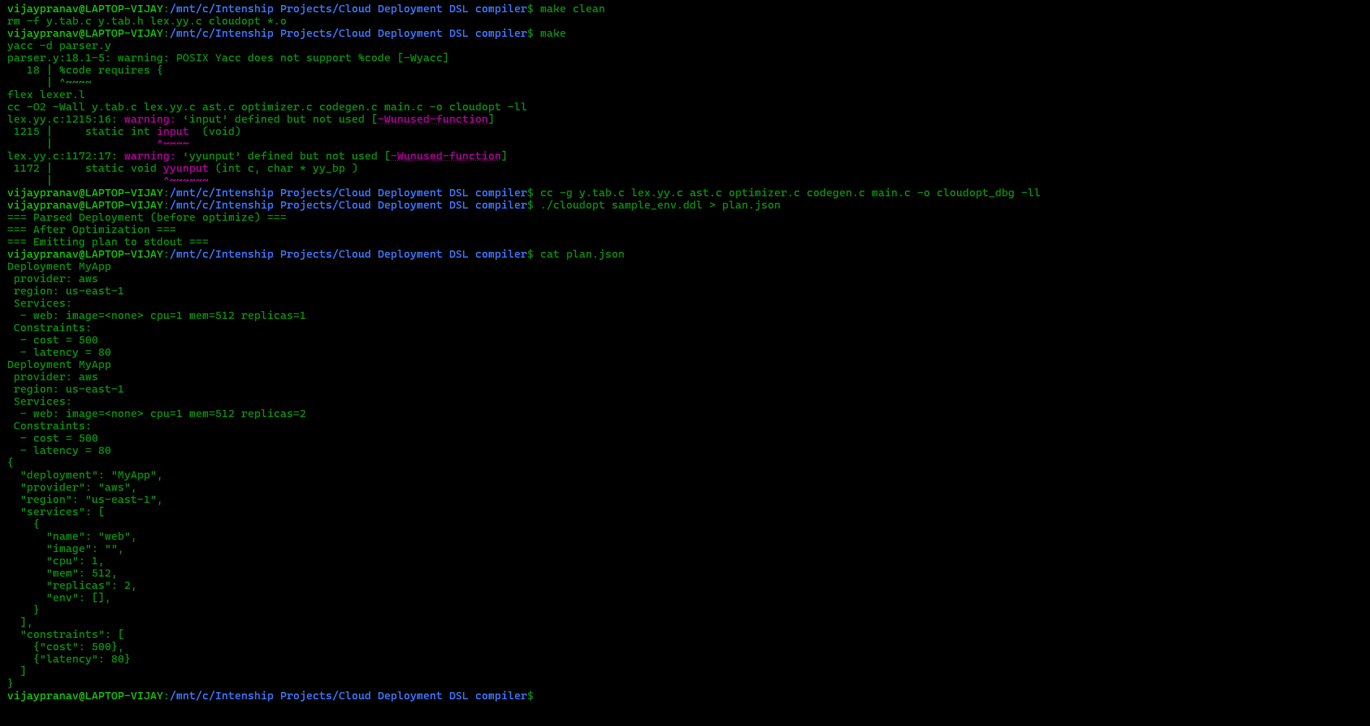
Enviroment Creation Using Make file

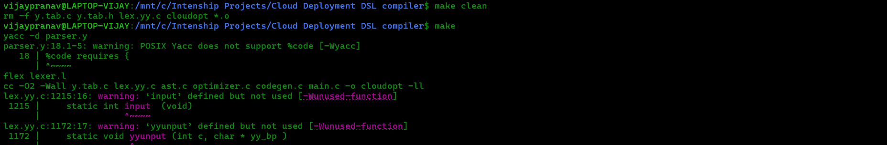

Compilation

Jason File Obtained As Output
